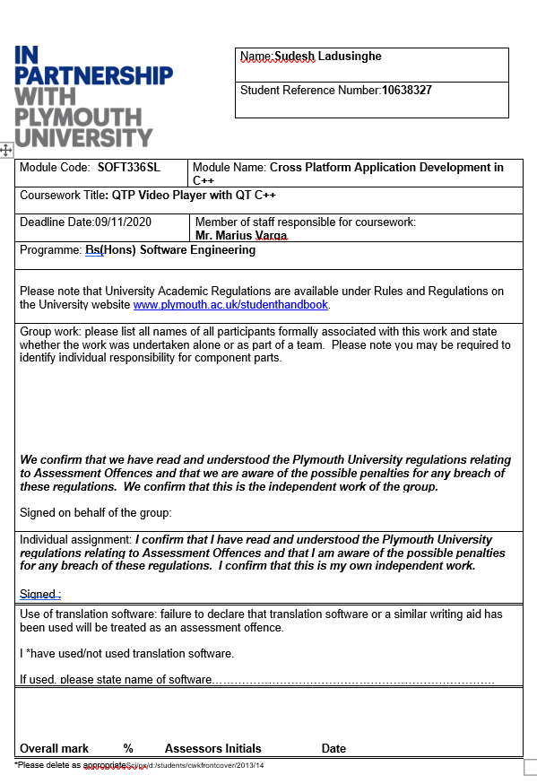

QTP VIDEO PLAYER



**Table of Contents**

1. Technical Documentation 4

1.1 GUI Description 4

1.2 Code Documentation 5

2. Non-Technical Documentation 7

2.1 Introduction 7

2.2 Scope 7

2.3 Functions/ User Manual 7

2.4 Known Bugs and Issues 12

2.5 Desired Improvements 13

2.6 Tested Platforms 13

2.7 Screenshots 15

# 1. Technical Documentation

## GUI Description

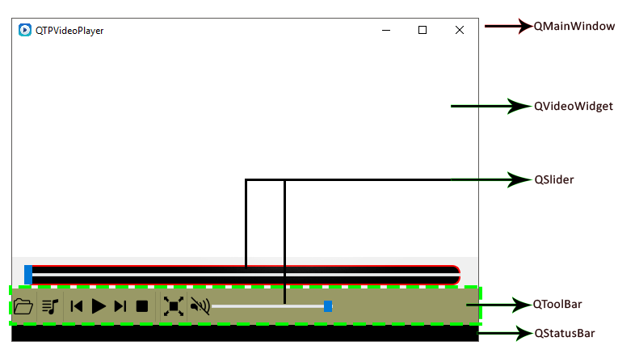

**QMainWindow**

QMainWindows is a place that the carried out pre-define place such as status bar, menu bar, tool bar and widgets for an application main windows.

**QVideoWidget**

This is a QT inbuilt class that provides a widget for display a video which produced by a media object. Only a single video display can be attached to a particular media object at once.

**QToolBar**

QToolBar has an ability to float and movable on QMainWindows. It is a horizontal bar that contains of Buttons, Sliders and other widgets. In this application, I don’t want the floating option and movable ability. So I manage to disable those functionalities.

**QStatusBar**

QStatusbar is a horizontal bar that can display the status of the application or any other message to the user. Those massages can be categorized as three categories. Temporary category can show a message to the user for a particular time period. In the Normal category can be stores messages that could be shows those at temporarily. Permanent category is never hidden and used for important mode indications.

**QSlider**

The QSlider is a widget for controlling a mentioned value range. User can able to move a slider vertically or horizontally and Slider returns the value of the stopped position of the slider.  
In My Application I used QSlider to handle volume, seek the position of the player as a horizontal manner.

**QFileDialog**

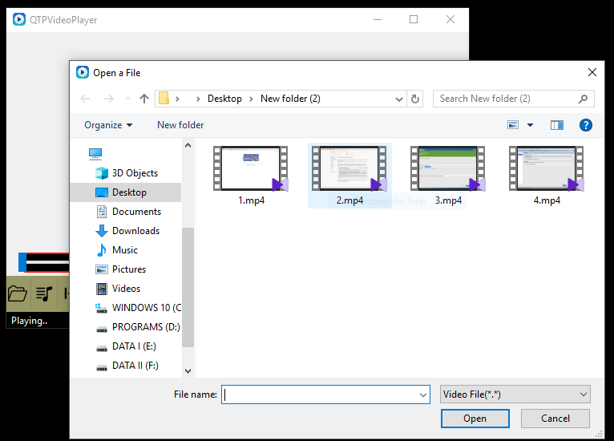

The QFlieDialog class is provides users to traverse the entire hard disk in order to select single or multiple files. In my QTPVideoPlayer I used QFileDialog class for open single file. In the playlist I used select and open to multiple files.

## Code Documentation

For the documentation of the code

Dioxygen application used to generate code documentation. Therefor find the attached folder called “Code Documentation” from the Main folder.

Dioxgen generates a final documentation as a .html file format. A web browser will need in order to open the Code documentation.

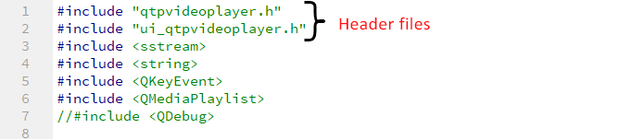  
  
  
  
  
  
  
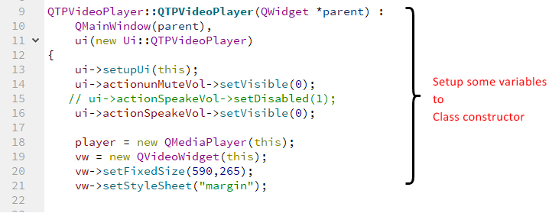  
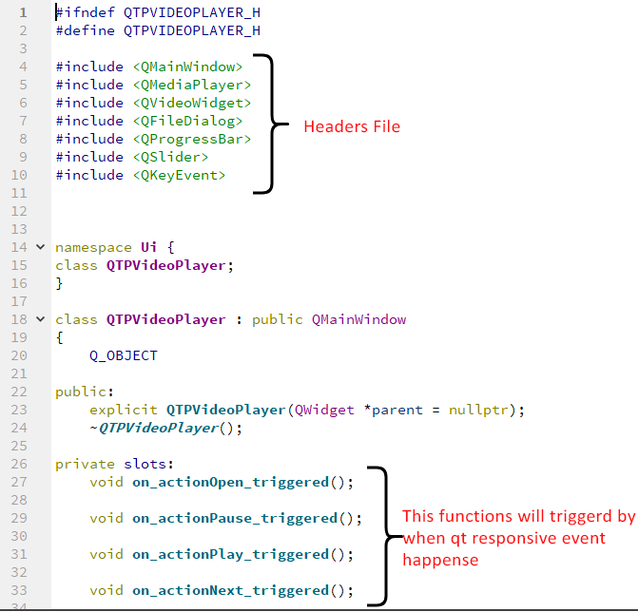

# 2. Non-Technical Documentation

## 2.1 Introduction

The main objective of this assignment is to make a cross-platform application with using QT and C++ programing language. This Project basically based on a developing a Video Player that run on multiple platforms. This Video player implemented for mainly Windows, Linux and Mac operating systems. Video player implemented by using QT creator with C++ language and some inbuilt QT classes.

## 2.2 Scope

This QTP Video Player will help to users to open video files that stores on their PCs. This application has basic abilities and functions that has any video player. The QTP Video Player also runs on multiple operating systems. Therefore, users have no hassle to thinks about the operation system that they have.

## 2.3 Functions/ User Manual

Funtionalites of the QTP Video Player can be numbered as like below 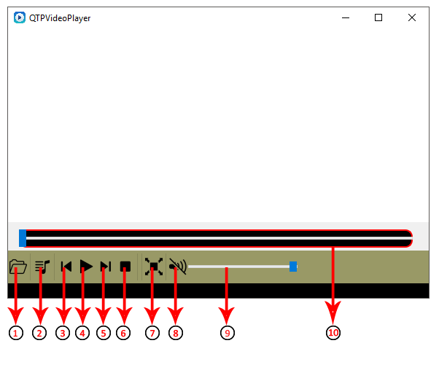

Number 1:  **Open a Video File**

This function will allow to user to select which file does want to open. If User press this button, Suddenly QTP Video Player will open a new window. Form that windows user can able to navigate the hard drive and find the file that he wants to play in QTP Video Player. File window that open by QTP video player is attached bellow. This function can only select one video file only.

Number 2: **Make a Playlist**

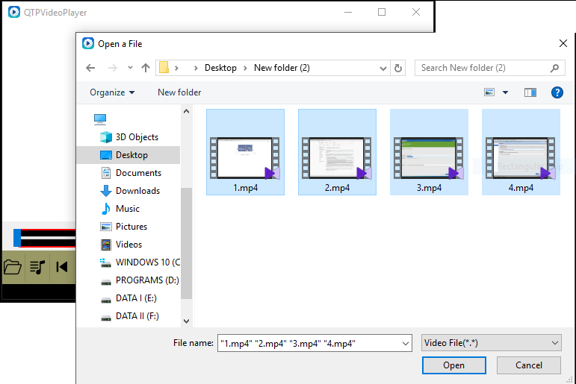This Function will allow to user create a playlist including more than one video file.

Number 3: **Play Previous Video File**

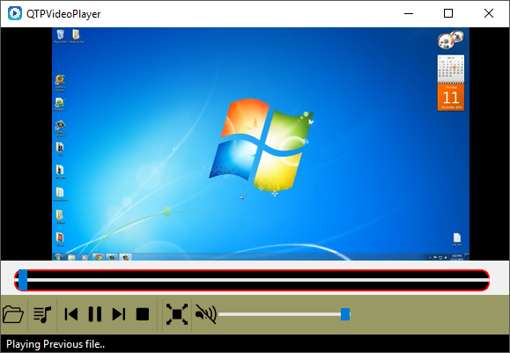This function will allow to user play previous Video File of the playlist the he created. This will only work with if the user makes a playlist. If users press this button when currently playing a video file which in middle of the playlist, suddenly the QTP Video player will play the previous file and notify a message to the user in status bar that saying “playing Previous file”.

Number 4: **Play/ Pause**

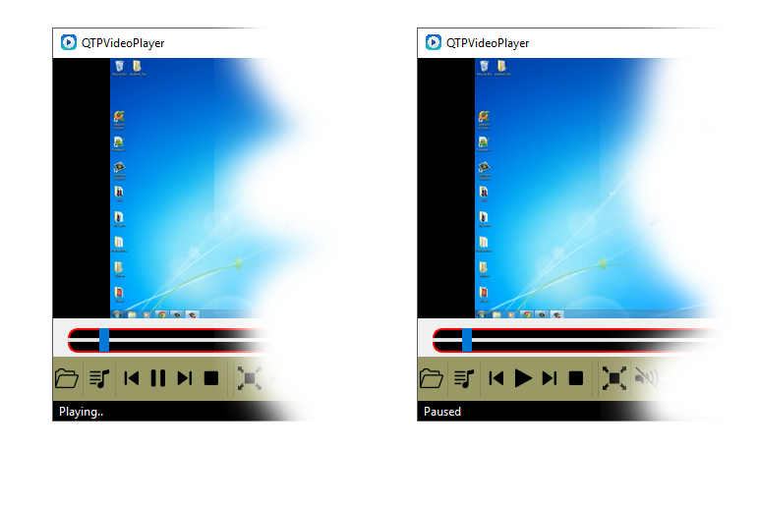User can pause a video file while it playing. Also User can play a video while it on pause mode. A message will display on the status bar state is it playing or pause.

Number 5: **Play Next Video File**

Giving this function to the QTP Video Player user will benefits playing the next file

Video File in the playlist they created early. Pressing this button QTP Video Player

Will play the next video and display a message “Playing Next File” on the status bar.

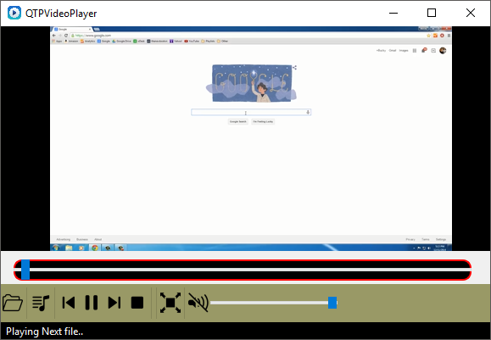

Number 6: **Stop**

This function is to the user need to stop what is playing on the player. After pressing the Stop button QTPV Player will stop playing until the user press the Play Button.

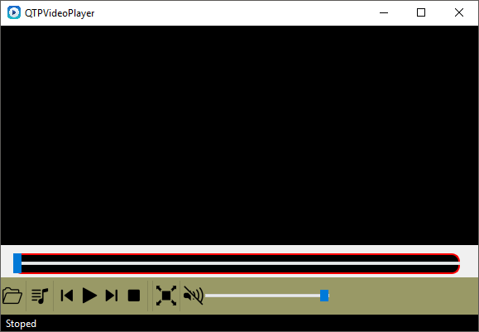

Number 7: **Full Screen**

This function will allow to user make the player full screen.

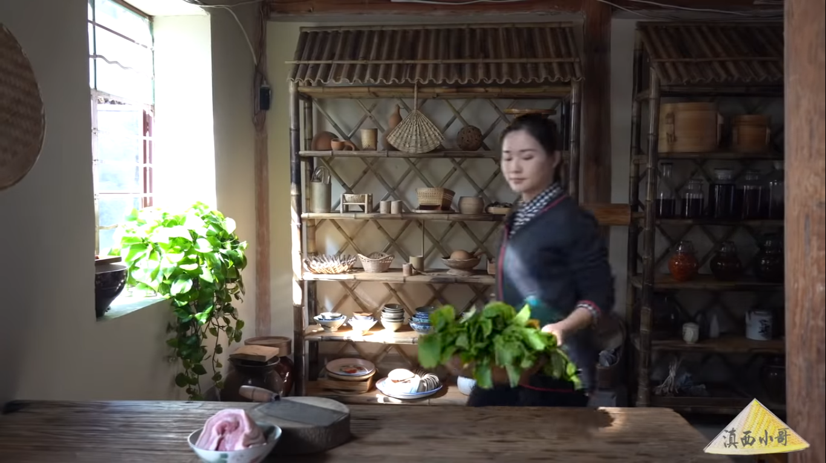

Number 8: **Mute/ Unmute**

This Function will allow to user to play the video without sound. If user want to mute the sound of the player, pressing this button it will happen.

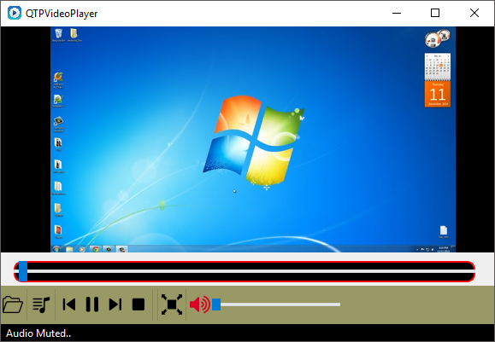 If the user wants the sound back, pressing the unmute button instantly sound will come back to volume level 45 of the QTP Video Player. This will indicate in the status bar.

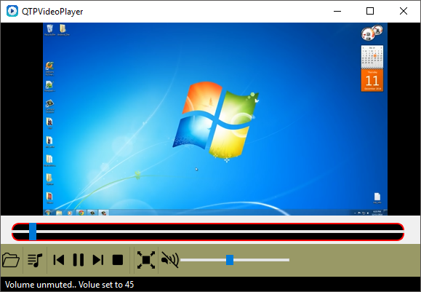

Number 9: **Volume Controller**

This function will control the volume of QTP Video player. Users can be controlling the Sound by adjusting the Volume Controller horizontally.

Number 10: **Seeker Bar**

This allow user to seek the video to where user to want to play specifically.

## 2.4 Known Bugs and Issues

QTP Video Player has existing some bugs because of the it is still on the first release.

Those Bugs are can be pointed as bellow.

* If the user clicks Full Screen Button, there is no way to roll back to normal screen size.
* User can change the volume by dragging the Volume bar, But User can’t get any idea how much is the current volume as a number.

## 2.5 Desired Improvements

Some advance Video Player functionalities will be adding to future versions of QTP Video Player. Such as,

* Add Subtitles
* Play Web videos with Web URL
* Shortcut keys
* DirectX Video Acceleration Support
* Convert the video file formats
* Screen Controlling such as adjusting Brightness, Hue, Contrast.
* Audio equalizer

## 2.6 Tested Platforms

The Current Version of QTP Video Player tested on,

* Windows 10
* Ubuntu 18.4
* MacOS Mojave 10.14

and the result was of the test is , QTP Video Player smoothly run on above mentioned Platforms .  
 **QTP Video Player running on Windows 10:**

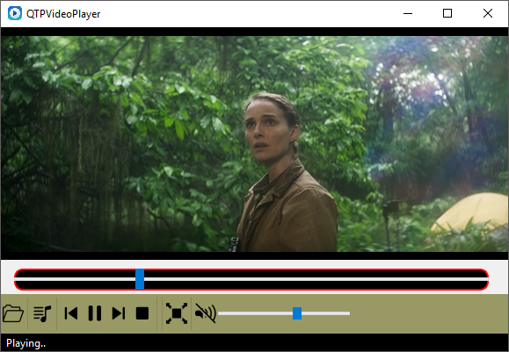

**QTP Video Player running on Ubuntu 18.4**

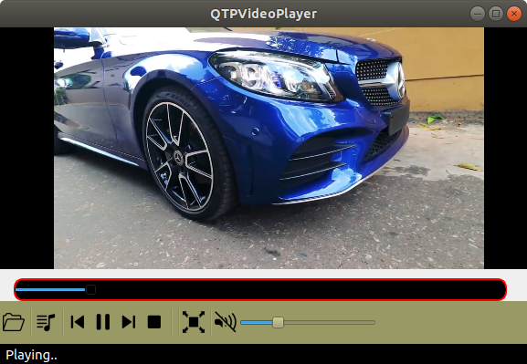

**QTP Video Player running on Mac OS Mojave 10.14**

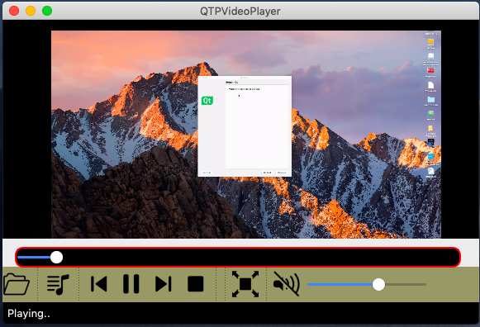

## 2.7 Screenshots

